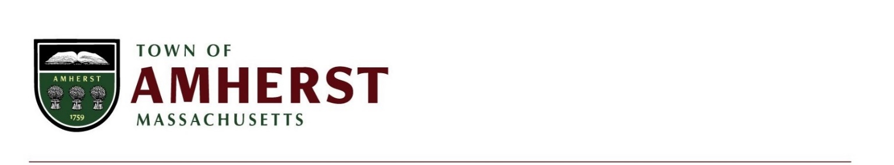
Conservation and Development
4 Boltwood Avenue
Amherst, MA 01002
(413) 259-3045
conservation@amherstma.gov

Valley Green Energy Working Group
Thursday, August 4, 2022
9:00 AM

Please note this a virtual meeting and will be located at: https://amherstma.zoom.us/j/86453438570

To join from a PC, Mac, iPad, iPhone or Android device:
Please click this URL to join. https://amherstma.zoom.us/j/86453438570

To join by telephone:
Dial (for higher quality, dial a number based on your current location):
US: +1 646 876 9923 or +1 312 626 6799 or +1 669 900 6833 or +1 253 215 8782 or +1 301 715 8592 or +1 346 248 7799 or +1 408 638 0968

Webinar ID: 864 5343 8570

International numbers available: https://amherstma.zoom.us/u/kcM57NoUkI

Meeting Agenda:

- Review Minutes of 7/22/22
- Updates
- Discussion – Outreach and Education Plan
- Public Comment
- Next Meeting Agenda
- Adjourn

